Pizza Sales SQL Queries
A.KPI
1. Total Revenue
Select sum(total_price) as Total_Revenue from pizza_sales;
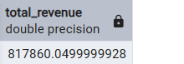

2.Avg order value
Select sum(total_price)/count(distinct order_id) as avg_order_value
from pizza_sales;
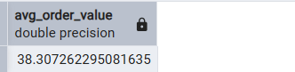

3.Total Pizza sold
Select sum(quantity) as Total_pizza_sold
from pizza_sales;
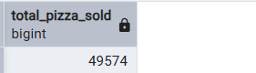

4.Total oder
Select count(Distinct order_id) as Total_order
from pizza_sales;
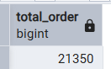

5.Total pizza per order
Select cast(cast(sum(quantity) AS decimal(10,2))/
cast(count(Distinct order_id)As Decimal(10,2)) As decimal(10,2)) as Total_pizza_per_order
from pizza_sales;
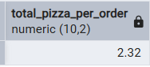

B.Daily Trend order name
Select To_char(order_date,'day') as order_day , Count(Distinct order_id) As total_order
from pizza_sales
group by To_char(order_date,'day');
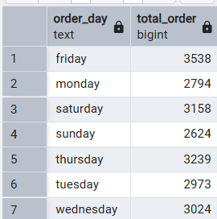

C.Monthly trend order
Select To_char(order_date,'month') as order_day , Count(Distinct order_id) As total_order
from pizza_sales
group by To_char(order_date,'month')
order by total_order DESC;
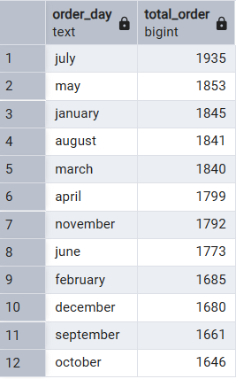

D.Percentage of sales by pizza category
Select pizza_category ,sum(total_price) As total_sales, sum(total_price) * 100/
(Select sum(total_price) from pizza_sales where Extract(Month from order_date) =1 ) AS Pct
from pizza_sales
where extract(month from order_date)= 1
Group by pizza_category;
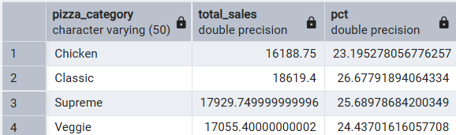

E.Percentage of sales Pizza size
Select pizza_size ,cast(sum(total_price) AS decimal(10,2)) As total_sales, cast(sum(total_price) * 100/
(Select sum(total_price) from pizza_sales Where Extract(quarter from order_date) =1) AS decimal(10,2)) AS Pct
from pizza_sales
Where Extract(quarter from order_date) =1
Group by pizza_size
order by Pct Desc;
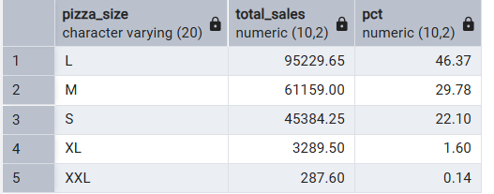

F.Top 5 best sellers by revenue,total quantity and total order
Select pizza_name, sum(total_price) As Total_revenue
from pizza_sales
Group by pizza_name
order by Total_revenue asc Limit 5;
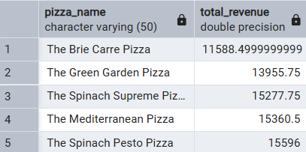
Select pizza_name, sum(quantity) As Total_quantity
from pizza_sales
Group by pizza_name
order by Total_quantity asc
Limit 5;
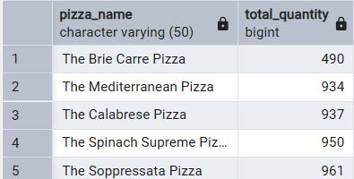

Select pizza_name, Count(Distinct order_id) As Total_order
from pizza_sales
Group by pizza_name
order by Total_order desc
Limit 5;
